BASIC OOP
1. Class Definition and the "Self" Keyword
A class is a blueprint. In Python, the syntax follows the class keyword. The most important concept to grasp is self. It is not a reserved keyword but a strong convention; it represents the instance of the object itself. It allows the code to distinguish between variables belonging to the class and local variables within a method.
Syntax:
Python
class ClassName:
def __init__(self, parameter1, parameter2):
self.attribute1 = parameter1 # Instance attribute
self.attribute2 = parameter2
2. The Constructor: __init__
The __init__ method is known as a Magic Method or Dunder Method (Double Under). It is automatically called when a new object is created. Its primary role is to initialize the state of the object (assigning values to its attributes).
3. Instance vs. Class Attributes
- Instance Attributes: Specific to each object (e.g., each MCU object has its own serial_number).
- Class Attributes: Shared by all instances of the class (e.g., all MCU objects belong to the Semiconductor category).
Syntax:
Python
class MCU:
category = "Semiconductor" # Class attribute

def __init__(self, model):
self.model = model # Instance attribute
4. Encapsulation and Access Modifiers
Python does not have strict private or protected keywords like C++. Instead, it uses naming conventions to signal how an attribute should be treated:
- Public: self.name (Accessible everywhere).
- Protected: self._voltage (Indicated by a single underscore; should only be accessed within the class or subclasses).
- Private: self.__secret_key (Indicated by double underscores; triggers "Name Mangling" to make it harder to access from outside).
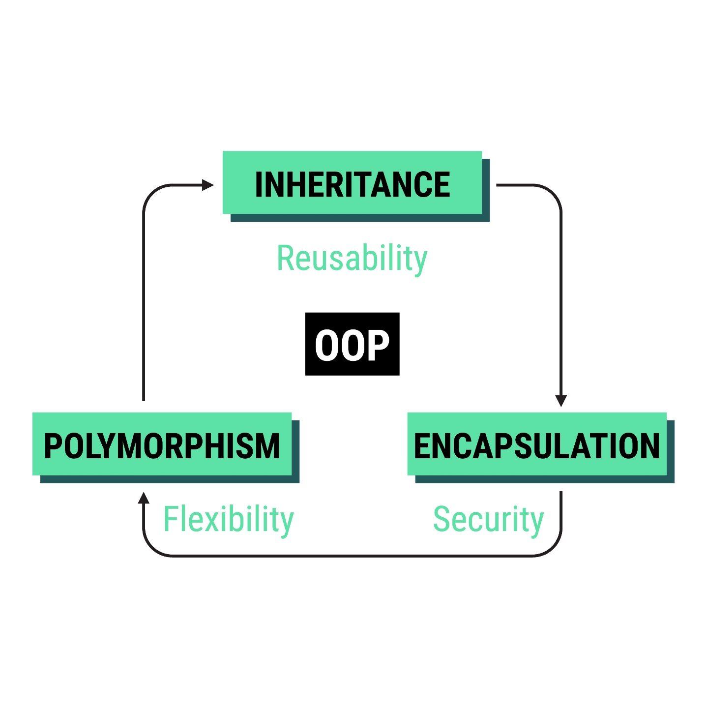
5. Inheritance and the super() Function
Inheritance allows a Subclass (Child) to acquire the properties and methods of a Superclass (Parent). The super() function is used to call the parent class's methods, specifically the constructor, to ensure all attributes are initialized correctly.
Syntax:
Python
class ChildClass(ParentClass):
def __init__(self, child_param, parent_param):
super().__init__(parent_param)
self.child_attr = child_param

